CAED LAB # 10

FA17-BECE-2001

RABIA

TASK1(1)

figure

x=(0:pi/50:2\*pi);

y1=sin(x);

y2=cos(x);

plot(x,y2,x,y1)

grid on

OUTPUT:

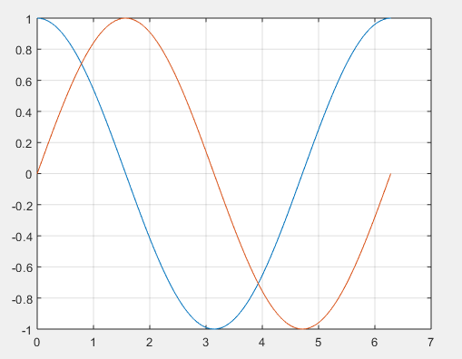

TASK1(2)

figure

x=(0:pi/50:2\*pi);

y1=sin(x);

y2=cos(x);

plot(x,y1,'--',x,y2,':')

grid on

OUTPUT:

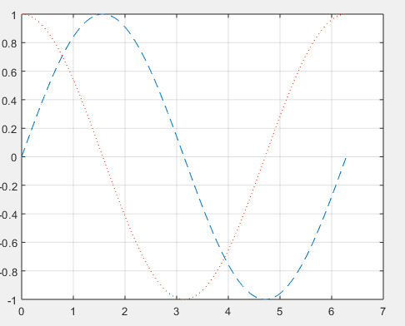

TASK2(3)

Code:

figure

x=(0:pi/50:2\*pi);

y1=sin(x);

y2=cos(x);

subplot(2,1,1)

plot(x,y1,'--g')

subplot(2,1,2)

plot(x,y2,':r')

legend('sin(x)','cos(x)')

xlabel("x")

ylabel("sin(x) and cos(x) waves")

title("Waves")

grid on

OUTPUT:

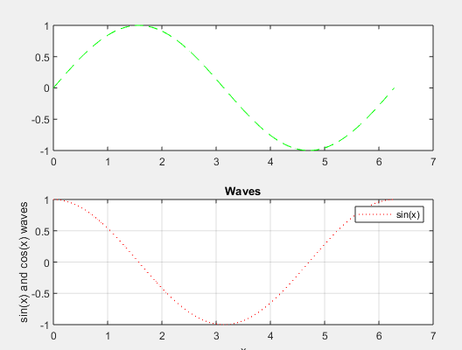

TASK#2

x=[0:0.01:4\*pi];

y=sin(x);

plot(x,y)

title("Plot of a Sine Wave")

ylabel("y values")

xlabel("x values")

grid on

figure(gcf)

OUTPUT:

